**Lab 5: Storage**

Paul Polsinelli

Information Technology, Arizona State University

IFT 472: Managing the Cloud

Professor Neff

Sep 13th, 2020

**Lab 5: Storage**

**Figure 1**

*A screenshot of new volume on the EBS Volume Page.*

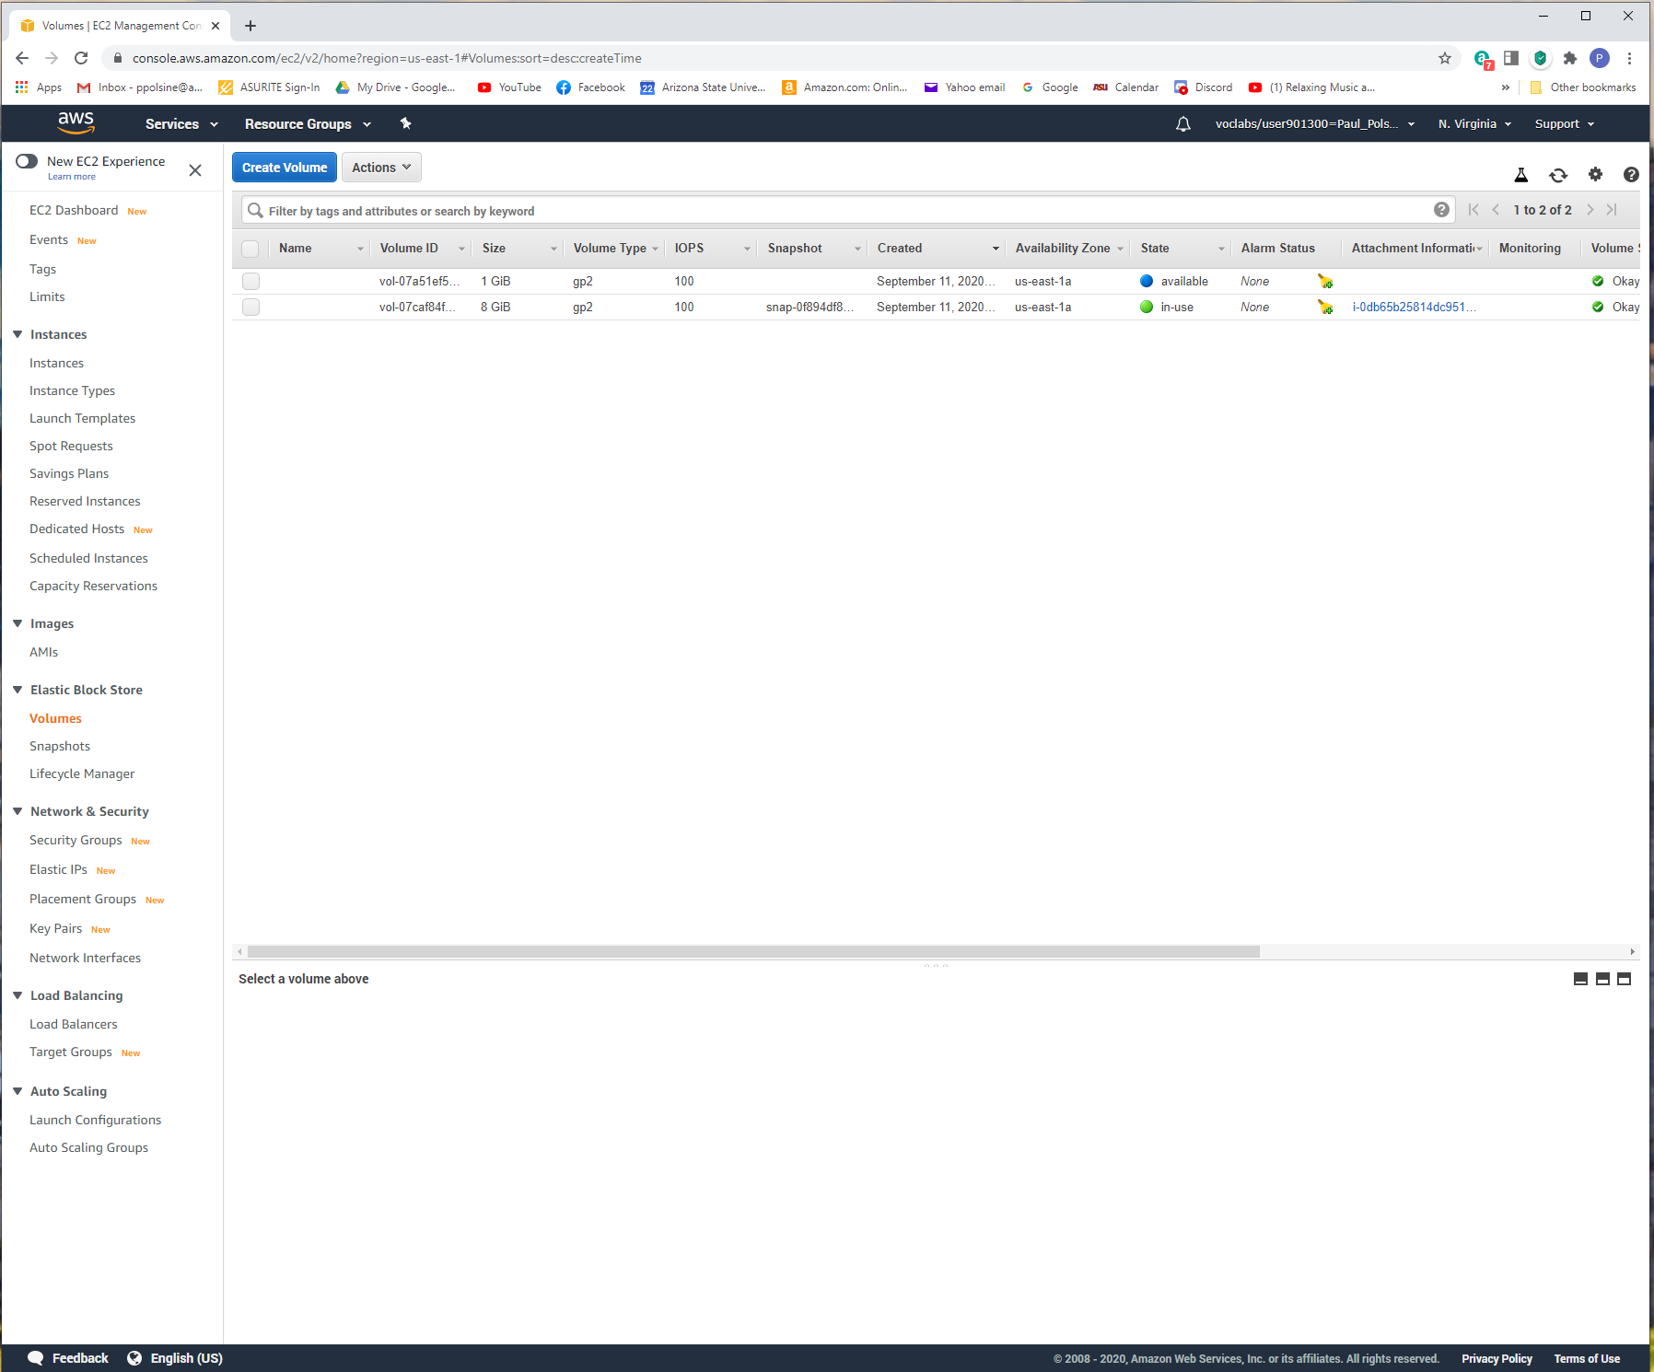

**Figure 2**

*A screenshot of new volume’s status “in-use”.*

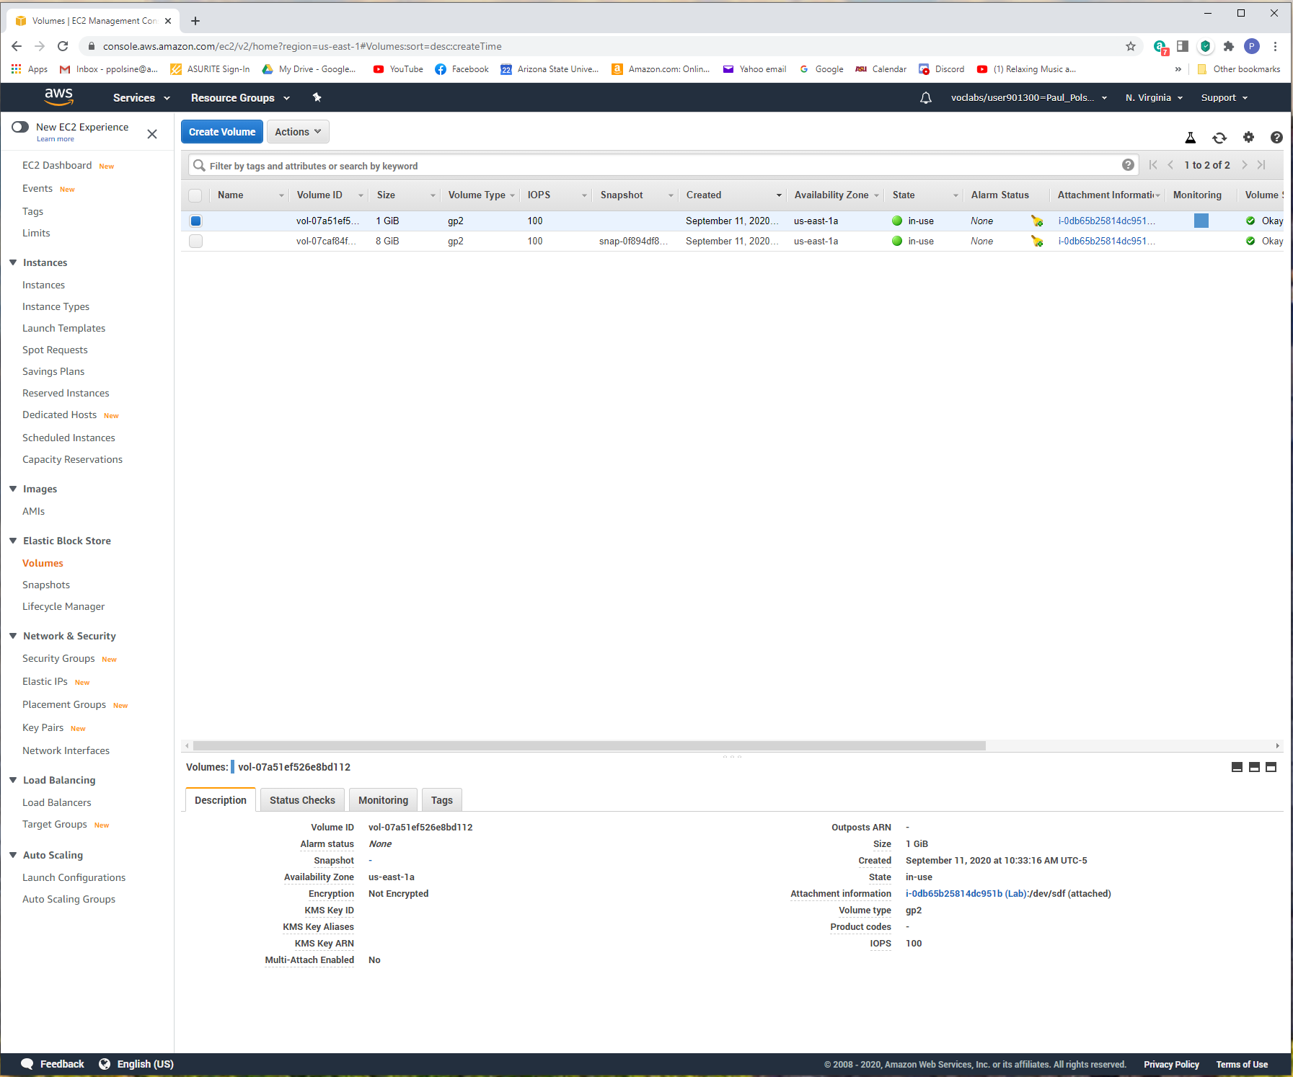

**Figure 3**

*A screenshot of the output of the cat command.*

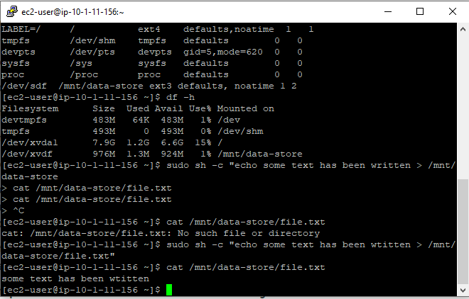

**Figure 4**

*A screenshot of output of the ls command.*

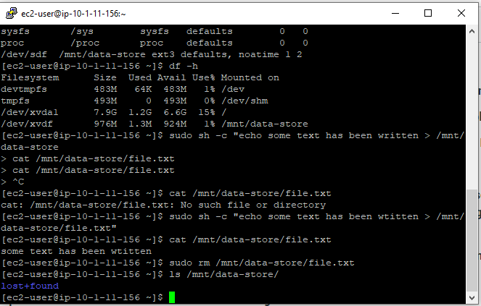

**Figure 5**

*A screenshot of output of the ls command.*

